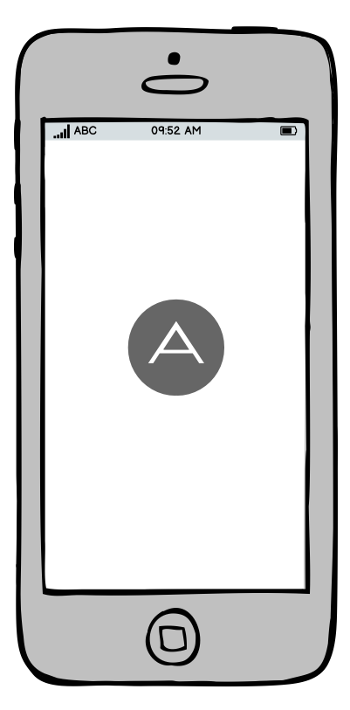
First Launch / Register

Process: On the first launch, generate a random ID using UUID().uuidString. Save this string to the iOS Keychain with the attribute kSecAttrAccessibleAfterFirstUnlockThisDeviceOnly.

Data in the Keychain is not deleted when the app is uninstalled. When the user reinstalls your app, it checks the Keychain, finds the old ID, and continues using it.

aft_register.php

{“uuid”: uuid}

Returns:
json_encode([
'status' => 'success',
'registration_id' => $publicKey
])

json_encode([
'status' => 'error',
'message' => 'Database error: ' . $e->getMessage()
])

Example:-

curl -X POST https://autoforwardtext.com/api/aft_register.php \
-H "Content-Type: application/json" \
-d '{
"uuid": "E621E1F8-C36C-495A-93FC-0C247A3E6E5F",
"details": {
"device_name": "iPhone 15 Pro",
"ios_version": "17.4",
"app_version": "1.0.0"
}
}'
{"status":"success","registration_id":"23cdcb158114d2e8364d7b2405153c37"}

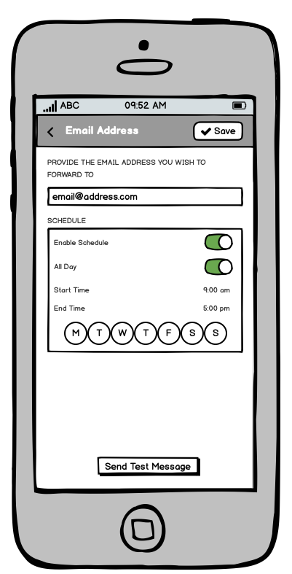

aft_saveemail.php

{“registration_id”:registration_id, “email_address”: email_value, “delete”: false}

Send delete=true; if deleting an email.

Success:-

json_encode([
'status' => 'success',
'message' => 'Email saved'
])

json_encode([
'status' => 'success',
'message' => $affected > 0 ? 'Email deleted' : 'Email not found'
])

Schedule logic is handled at the device end.

curl -X POST https://www.autoforwardtext.com/api/aft_saveemail.php \
-H "Content-Type: application/json" \
-d '{"registration_id": "23cdcb158114d2e8364d7b2405153c37", "email_address": "test@example.com", "delete": false}'
{"status":"success","message":"Email saved"}

curl -X POST https://www.autoforwardtext.com/api/aft_saveemail.php \
-H "Content-Type: application/json" \
-d '{"registration_id": "23cdcb158114d2e8364d7b2405153c37", "email_address": "test@example.com", "delete": true}'
{"status":"success","message":"Email deleted"}

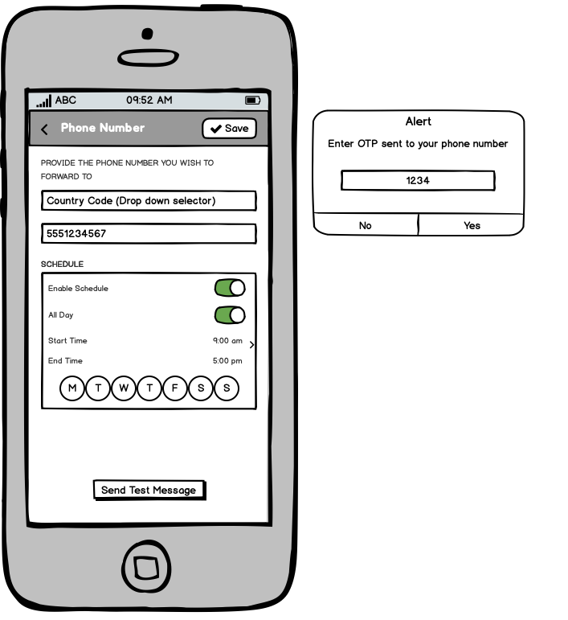

aft_reqotp.php

Send JSON with:-

registration_id
phone_number

Returns
json_encode(['status' => 'success', 'message' => 'OTP sent to your phone']);
json_encode(['status'=>'error','message'=>'Daily limit reached'])

curl -X POST https://www.autoforwardtext.com/api/aft_reqotp.php \
-H "Content-Type: application/json" \
-d '{"registration_id": "23cdcb158114d2e8364d7b2405153c37", "phone_number": "+1234567890"}'
{"status":"success","message":"OTP sent to your phone"}

aft_savenumber.php

Send JSON with:-

registration_id
phone_number
otp_code

Returns:
json_encode(['status' => 'success', 'message' => 'Phone verified and saved'])
OR
json_encode(['status' => 'error', 'message' => 'Invalid or expired OTP'])

curl -X POST https://www.autoforwardtext.com/api/aft_savenumber.php \
-H "Content-Type: application/json" \
-d '{"registration_id": "23cdcb158114d2e8364d7b2405153c37", "phone_number": "+1234567890", "otp_code": "084518"}'
{"status":"success","message":"Phone verified and saved"}

aft_delnumber.php

Send JSON with:-

registration_id
phone_number

Returns

json_encode([
'status' => 'success',
'message' => 'Phone number deleted successfully.'
])

json_encode([
'status' => 'error',
'message' => 'Phone number not found for this device'
])

curl -X POST https://www.autoforwardtext.com/api/aft_delnumber.php \
-H "Content-Type: application/json" \
-d '{"registration_id": "23cdcb158114d2e8364d7b2405153c37", "phone_number": "+1234567891"}'
{"status":"success","message":"Phone number deleted successfully"}

aft_saveurl.php

Send JSON with:-

registration_id
url
is_slack
delete [optional]

Response (one of)
json_encode([
'status' => 'success',
'message' => 'Endpoint saved'
])

json_encode([
'status' => 'success',
'message' => $affected > 0 ? 'Endpoint deleted' : 'Endpoint not found'
])

json_encode(['status' => 'error', 'message' => 'Database error'])

curl -X POST https://www.autoforwardtext.com/api/aft_saveurl.php \
-H "Content-Type: application/json" \
-d '{"registration_id": "23cdcb158114d2e8364d7b2405153c37", "url": "https://hooks.slack.com/services/...", "is_slack": true, "delete": false}'
{"status":"success","message":"Endpoint saved"}

aft_forward.php

Send JSON with:-

registration_id
message
sender
timestamp

Returns

json_encode([ 'status' => 'success', 'details' => ['sent' => $dispatchCount, 'failed' => $errorCount] ])

This service is called when the Shortcut’s Automation calls the APP for processing.
The schedule feature must be handled at the iOS App End.

curl -X POST https://www.autoforwardtext.com/api/aft_forward.php \
-H "Content-Type: application/json" \
-d '{
"registration_id": "23cdcb158114d2e8364d7b2405153c37",
"message": "Hello from my iPhone!",
"sender": "+19998887777",
"timestamp": "2026-01-10 12:00:00",
"subject": "Inbound SMS"
}'
{"status":"success","details":{"sent":2,"failed":1}}

aft_test_connection.php

{ "registration_id": "YOUR_MD5_KEY", "type": "email", "target": "user@example.com", "message": "This is a test from my iOS app!" }

// 'email', 'webhook', or 'phone'
// is_slack

Returns:

json_encode(['status' => $success ? 'success' : 'failed'])

Please manage IAP in the app itself at this time, in the future we will use RevenueCat or something to streamline performance.

curl -X POST https://www.autoforwardtext.com/api/aft_getprofile.php \
-H "Content-Type: application/json" \
-d '{"registration_id": "23cdcb158114d2e8364d7b2405153c37"}'
{"status":"success","profile":{"registration_date":"2026-01-09 20:24:09","subscription":{"status":"expired","product_id":"none"},"destinations":{"emails":[{"email":"zeeshanrxs@gmail.com","created_at":"2026-01-09 20:28:12"}],"phones":[{"phone_number":"+1234567890","created_at":"2026-01-09 20:32:07"}],"webhooks":[{"url":"https:\/\/hooks.slack.com\/services\/...","is_slack":"1","created_at":"2026-01-09 20:35:00"}]}}}

